### **Task 2: Data Insertion and Handling Nulls**

#### **Objective**

Practice inserting, updating, and deleting data in a database.

#### **Tools Used**

* DB Fiddle / SQLiteStudio

#### **Deliverables**

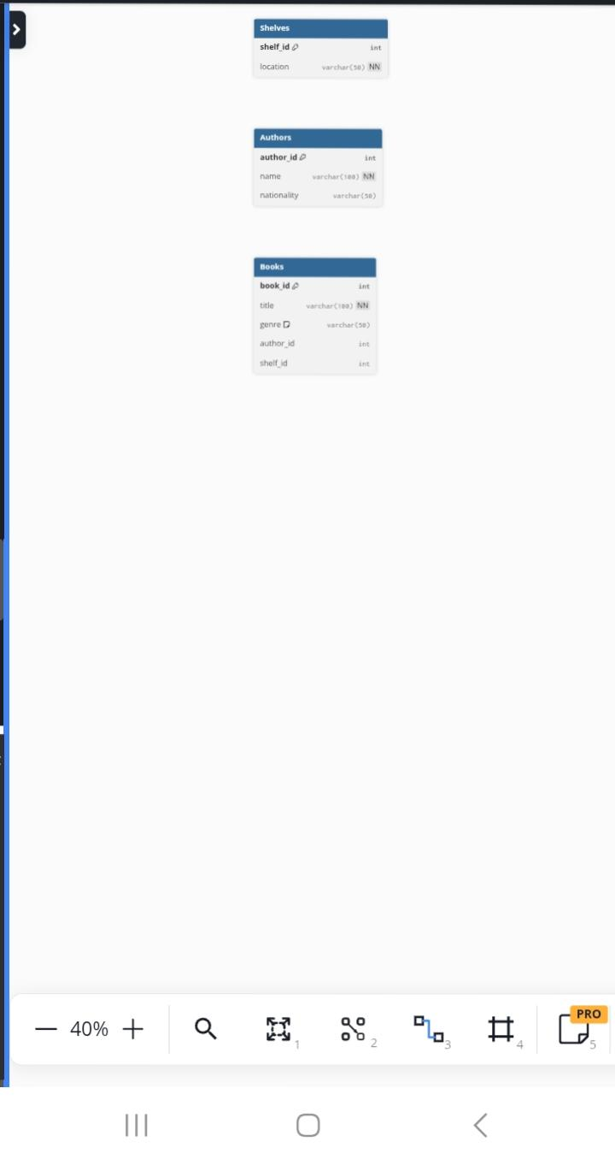

#### **Schema Used** (Library Example)

Table Authors {

author_id int [pk]

name varchar(100) [not null]

nationality varchar(50)

}

Table Shelves {

shelf_id int [pk]

location varchar(50) [not null]

}

Table Books {

book_id int [pk]

title varchar(100) [not null]

genre varchar(50) [default: 'Unknown']

author_id int

shelf_id int

}